XenoHammer
Interim Game Design

Team - Cult of Cactaur
Brian Smith
Chris Haire
Roger Norris
Jason Shelton

Genre – 2D Space shooter with RPG Flare
Technical Focus - Single player, 1 level (divided into 3 sub levels)

Screen Shots

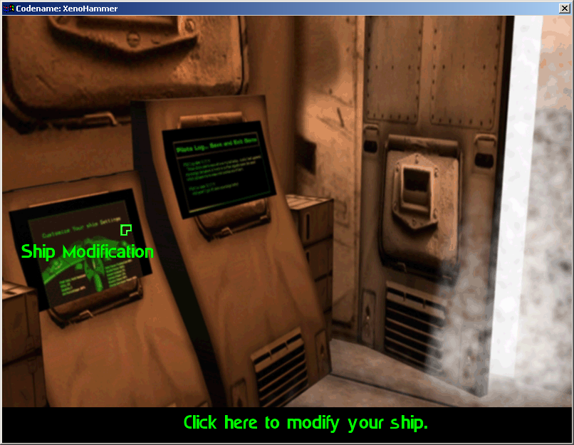

Pilot Briefing Area
- Leftmost screen – The player clicks to make modifications to ship before launch
- Middle screen – The player clicks to save and exit the game (Save not yet implemented)
- Hangar Door – The player clicks here to launch into action
- Notice – The name of the screen pops up over the object when the mouse moves over it. The action the object performs is explained in the textbox at the bottom of the screen. We feel this provides all the needed cues for the player to interact with a “non-standard” interface. Also, note the customized cursor.

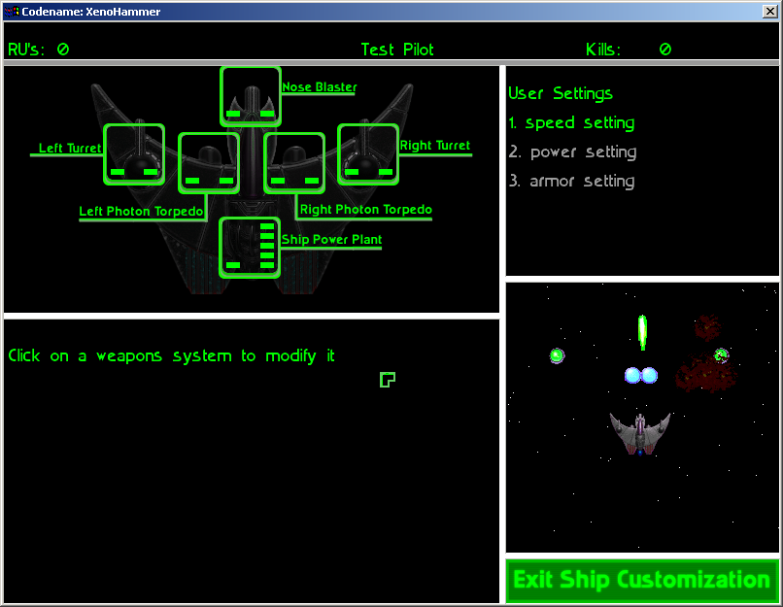
Ship Modification Screen

The player is presented with a variety of upgrade options here:
- Pilot statistics frame – lists all the current stats of the pilot.
- Ship Energy Frame - The frame that contains the ship with all the energy settings and is used to indicated what each system is currently set at.
- User Settings Frame – Indicates which setting (or hotkey) the player is currently setting the ship energy settings to.
- Weapons modify Frame – will contain needed information on how to upgrade each weapon.
- Ship Firing Frame – this frame will contain a real time rendering of the ship firing all weapons with the current energy settings. This will allow the player to have a sense of how different upgrades affect ship performance.
- Exit Ship Customization – saves these settings and exits back to the “Briefing room”
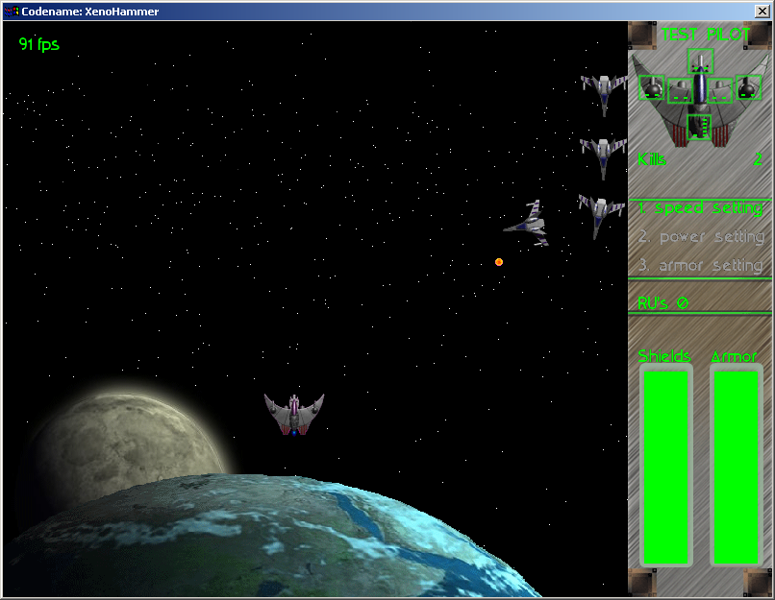
Start of Game

The player ship is located roughly in the center of the screen. The ships in the upper right side of the play area are light fighters performing their “Follow the Leader” AI until they break off and attack separately.

Console

The console is located on the right side of the screen and represents all the information that the player needs to know about the ship and the player status.
(starting from the top)
- “Test Pilot” - This is the current rank of the pilot, this number is based off the current number of kills out of the total number of possible kills. The more accurate and efficient the player is at killing enemies, the higher rank they will get.
- Ship Diagram w/ energy overlay – This represents the energy settings of each weapon or energy system on the ship. We have used a natural mapping that maps the energy setting over the physical location of that weapon on the ship. These are the same energy settings that were predefined by the player in the “Ship Modification Screen”
- Kills – A basic kill counter for each enemy destroyed.
- Energy presets – Assigned to hotkeys, these presets defined by the player allow the ship to change into different modes depending on the situation. (See original design doc)
- RU’s – Total amount of collected resource units, used to purchase upgrades.
- Shields and armor – gradient colored bars that represent the numerical value remaining in the player ships shield or armor.

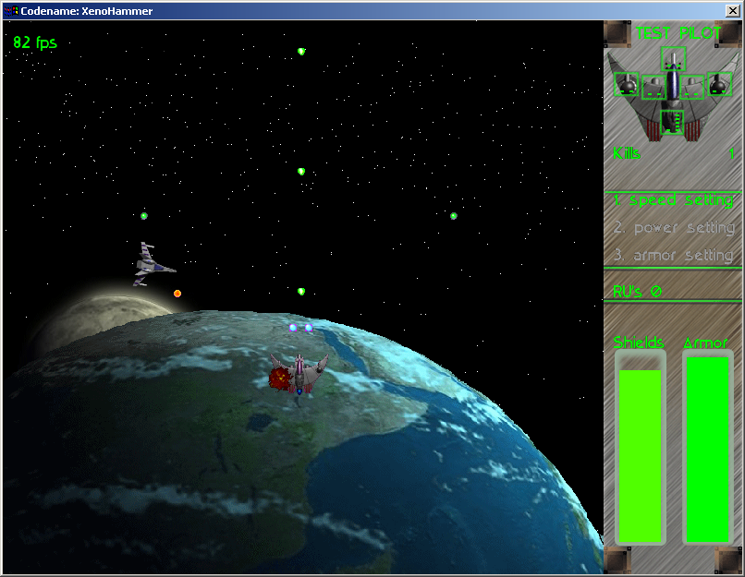
Basic attack and player damage

Here we see the player firing all the weapons. Make note of the relatively small size of the projectiles. This is due to the low damage value of them, since they are all set to a power of 1 in their energy settings. The light fighter has fired and successfully hit the player ship. The damage can be seen as a visible explosion on the outer hull of the ship and a notable decrease in shield strength.

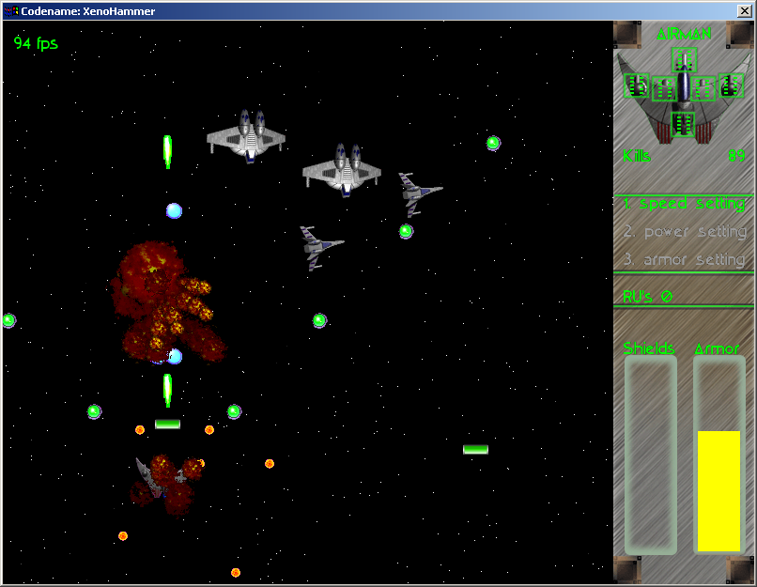

Upgraded player ship, Gunships and resources

The player ship has been upgraded to full power. The size of the projectiles is much greater than before and they also carry a proportional damage increase. The player has sustained heavy damage from both the Gunships and the Light Fighters. This is evidenced by the explosions that partially occlude the playership. Once shields have run out they will still attempt to recharge, but armor that is lost will never replenish. Player ranking has increased to “Airman” as a result of 89 kills. The green horizontal bars floating in the play area are resources that have been dropped by destroyed ships. The player must collect these by running into them to get RU’s for later upgrades.

Completion to Date

Functional Minimum – (Sept 25th)
Skeleton engine functionality, | Complete
1 enemy with ability to shoot bullets (non intelligent), | Complete
player ship with ability to shoot bullets, | Complete
simple bounding box collision detection, | Complete
enemy kill counter | Complete

Low Target – (Oct 15th)
Engine core completed, | Complete
pixel level Collision detection, | Complete
enemy shoots pseudo intelligently, | Complete
Startup screen, | Complete
1 full level, | Complete
real-time statistics on ship updated in console, | Complete
simple sound effects | Complete

Desirable Target –(Nov 10th)
2 levels,
collection of resources, | Complete – 1 or 2 resources?
scoring system (kills and pilot ranking), | Complete – update based on gameplay
in game variant energy settings,
real enemy AI (with ability to turn ships dynamically), | Complete
2 types of enemies, | Complete
all 3 player weapons have 5 different firing modes, | Complete
finalized sound effects,
in between level ship setup GUI, | 35%
player/ship save

High Target – (Dec 7th)
3 levels, w/ boss,
5 enemy ships with varying difficulty,
Upgrade weapons (rotating turrets and homing missiles),
music,
explosion generator | Complete –update sizes of explosions

Difficulties
- Clanlib
- Libraries are not completely stable
- Forced to work around numerous bugs
- Provided documentation does not always match actual libraries
- However, developers have been helpful and have answered questions and fixed bugs we’ve discovered

- Game Engine
- Building a scalable engine that performs well on various systems was more difficult than expected
- Random memory access errors and memory leaks have been hard to debug and fix
- Completing reliable collision detection took more time than anticipated

- User Interface
- Presenting and balancing the amount of information provided to user during game play via the console has been difficult
- Customizing ship GUI more difficult than expected

- Game Play
- Balancing multiple resource types to collect

- Sound
- Creating sound effects that appear to be synchronized with graphical objects was harder than expected

As a result of our extensive planning and attention to detail in the first specification, there is little that has actually changed during our preliminary implementation. During the process of detailing our original spec we discarded two ideas that we originally wanted to have included in our game. These ideas consisted of a universal ship power plant that would allow any number of power configurations and allowing the user to interchange weapons and their locations on the ship. Our first design reflected these omissions because we felt they would add unnecessary complexity to both the game play and implementation. Instead of allowing users to move power from one part of the ship to another, we limit the user to adding power to a specific weapon or ship system and once the power has been added, it remains in that system. Additionally, all weapons are static and cannot be changed or moved, but may be upgraded. We feel these were important decisions because as the game comes together it is evident that we were correct in the assumptions that we made in our original analysis. The list of difficulties above would have been much larger had we chosen to go with our first specification. We feel that the extensive team analysis of these issues has proved to be very fruitful. Even with the extensive planning we have done, we are in the midst of a possible change to the original project plan as a result of the game play issues we have noticed. Originally, we were going to have multiple resource types for the user to collect. However, in an effort to reduce the level of complexity of the system we are leaning towards only using one type of resource for all ship upgrades.

What’s Next?

Since we are ahead of schedule in our implementation of the game, balancing different variables in the game is going to be the majority of our focus for the last half of our project. Examples of variables that need to be balanced our:
- Player weapons, both strength and rate
- Player ship armor, shot rate, shot damage, speed of movement, shield recharge speed
- Enemy ships armor, speed, kamikaze damage, weapons damage, shield levels(or lack of shield)
- Resource collection and relationship to upgrades
- Ranking levels and how many kills to reach each level

By finding the right balance of such variables, the game play will be enhanced by providing the user with the right level of difficulty. Otherwise, the game could seem tedious if the game is too difficult or unchallenging if the game is too easy.

